A PROJECT REPORT
ON
"Clay Pottery & Sandstone"
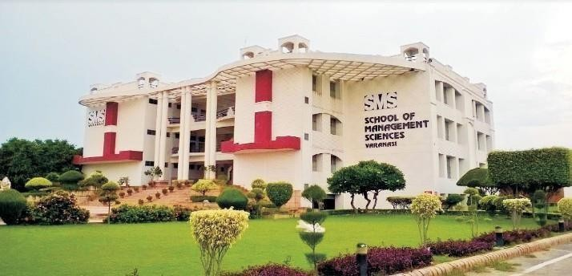

Submitted in partial fulfillment of the requirements for the three years

BACHELOR OF COMPUTER APPLICATIONS
(Affiliated to Mahatma Gandhi Kashi Vidyapith Varanasi, Uttar Pradesh)

SESSION-2025-26

Under Supervision of:
Mr. Vipin Maurya
(Assistant Professor)
Submitted By:

Ansh Singh
BCA2326042





CERTIFICATE

Certified that this Project Report entitled
“………………………………………………………………………………………………………………………………….” has been prepared by
Mr./Ms. ………………………………………………………… of the
BCA- Vth Semester during the Session 2025-2026 under my supervision.

This Project Report is as per standard and I forward it to the Director, S.M.S. for getting it evaluated as per the Ordinances governing the BCA Course.

Date: ............ ………………………….
(Signature of the Supervisor)

………………………..
(Name of the Supervisor)

……………………..
(Designation)

ACKNOWLEDGEMENT
First, I would like to thank almighty for keeping me healthy and active because of which I was able to complete my project successfully.
I express my sincere and heartfelt gratitude to Prof. P.N. JHA (Director) of SMS, Varanasi who gave me such a great opportunity to work on a project where I can show my creativity, Prof. Kamal Sheel Mishra (HOD), Computer Science for his moral support and my mentor Mr. Vipin Maurya (Assistant Professor), SMS Varanasi for providing me knowledge, guidance, and full cooperation extended during the perusal of my project.
I would also like to acknowledge and thank Prof. Aditya Kumar Gupta (Coordinator of BCA), who helped me and enlighten my path. This report is the outcome of the support which I have received from people directly or indirectly.
Finally, I would like to show my gratitude to all my family members, friends, faculty members of SMS, Varanasi whose guidance have helped to complete this project.

DECLARATION

I am Ansh Singh, student of School of Management Sciences Varanasi hereby declare that the project work entitled “Clay Pottery & Sandstone” submitted by me to “School of Management Sciences, Varanasi”, in partial fulfillment of the requirement for the degree of Bachelor of Computer Applications (BCA) is a record of the project work carried out by me under the guidance and support of Mr. Vipin Maurya (Assistant Professor).

I further declare that the work reported in this project has been submitted and will not be submitted either in part or in full, for the award of any other degree or diploma in this institute or any other institute or university.

Name: Ansh Singh
[BCA Vth Semester] Roll No: BCA2326042

TABLE OF CONTENT

S. NO | CONTENTS | PAGE NO.
1. | Introduction
 | Introduction of the Project | 1
 | Purpose of the Project | 1
 | Problems in the Existing System | 1-2
 | Solution to the Problem | 2
2. | Feasibility Study
 | Technical Feasibility | 3
 | Operational Feasibility | 4
3. | System Analysis
 | Study for the System | 5
 | Proposed System | 5
 | Input and output | 5
 | Process Models used with justifications | 6
4. | Software Requirement Specifications
 | Hardware Requirement | 7
 | Software Requirement | 7
5. | System Design
 | Data Flow Diagram | 8-9
 | E-R Diagram | 10
6. | Conclusion | 11
7. | Future Scope | 12
8. | Bibliography | 13

  - INTRODUCTION

Introduction of the Project

This project focuses on building an e-commerce platform dedicated to Clay Pottery and Sandstone products. Many artisans in India create beautiful handicrafts but struggle to reach national or international customers. This website allows artisans to showcase their products online, while customers can browse, select, and purchase items easily. The system bridges the gap between artisans and buyers and promotes Indian traditional art globally.

1.2 Purpose of the Project
The Purpose of this project is to provide a digital marketplace where local artisans can sell their handcrafted products directly to customers. The system ensures wider market reach, improved income opportunities, and preservation of traditional Indian art.
- To remove the dependency on middlemen and allow artisans to earn fair and better profits.
- To create a simple and user-friendly platform where customers can easily browse and purchase authentic handmade products
- To promote Indian clay pottery and sandstone craftsmanship at national and international levels.
- To support rural and small-scale artisans by giving them a stable and organized online selling environment.
- To encourage digital transformation in the handicraft sector and help artisans adapt to modern online business trends.

1.3 Problems in the Existing System
- In the traditional system, artisans depend on local shops and middlemen. They face issues such as.
- Limited customer reach:
- Artisans can sell only within their local area. People outside their town or city do not get to see or buy their products.
- No proper platform to showcase products:
  - There is no online platform where artisans can display their items with photos, descriptions, and prices. So their products cannot reach a wider audience.
- Low income due to middlemen:
- Middlemen take a large share of the profit. Because of this, artisans do not receive the full value of the products they create.
4. No digital catalog or branding:
- Artisans do not have an online catalog or brand identity. Without proper presentation, customers cannot recognize their products easily.
5. Difficulty in connecting with national/international buyers:
- Artisans have no way to reach customers from other states or countries. Limited communication and absence of online presence result in fewer business opportunities.

1.4 Solution to the Problem

This e-commerce website provides:
- A direct platform for artisans and customers:
  - The website allows artisans to sell their products directly to customers without involving third parties. This helps build direct communication and trust between both sides.
- Online product display with images, descriptions, and prices:
  - Artisans can upload photos, details, and prices of their products. Customers can easily view and compare items before buying, just like a professional online shop.
- Secure purchase and order management:
  - Customers can place orders safely, and the system keeps track of all orders. This ensures proper delivery, clear records, and smooth transactions.
- No middlemen, ensuring higher profit for artisans:
  - Since the product is sold directly to the customer, artisans do not have to give a part of their earnings to middlemen. This increases their overall income.
- Wider reach through digital marketing:
  - The website makes it possible to promote products online through social media, SEO, ads, and other digital tools. This helps artisans reach customers across the country and even internationally.

FEASIBILITY STUDY

2.1 Technical Feasibility
- Hardware Feasibility:
- The hardware required for this project is easily available and affordable. A basic system with an Intel i3/i5 processor, 4-8GB RAM, and 256GB SSD is sufficient for development. The website will run on any standard Apache or Node.js server without needing high-end hardware.
- Software Feasibility:
- The Project uses standard web technologies such as HTML, CSS, JavaScript for the frontend and PHP or Node.js for backend scripting. MySQL is used as the database, which is reliable and easy to maintain. These technologies are widely supported and make the system simple to develop and scale.
- Development Approach:
- The Prototype Model is used to build the system. It helps create an early working model of the e-commerce website, allowing artisans and users to give feedback. This reduces errors, improves understanding of requirements, and increases the quality of the final system.
- Scalability:
- The modular architecture, including route optimization, pin-code mapping, and task assignment systems, allows for easy scaling to additional regions or features.
- Compatibility:
- Standard web technologies ensure compatibility across various devices and browsers, making the system accessible to a broad user base.
- Resource Efficiency:
- Route optimization algorithms reduce operational costs and environmental impact, aligning with sustainability goals.
These points collectively demonstrate that the system is technically feasible with current resources and technology.

2.2 Operational Feasibility
- User-Friendly Interface:
  - The platform offers a clean and simple interface that artisans and customers can navigate easily. Artisans can upload products without technical knowledge, and customers can browse and purchase items effortlessly.
- Effective Product and Order Management:
  - Modules like product upload, cart, and order tracking help users operate the system smoothly. Artisans and admin can manage inventory, and customers get clear information about their orders.
- Optimized Operations:
  - The website reduces manual processes such as offline communication and physical product showcasing. This improves efficiency and saves time for both artisans and customers.
- Scalability of Operations:
  - As more artisans join, the system can handle multiple products and users without performance issues. It supports expansion to more regions and customer groups.
- Customer Convenience:
  - Customers can explore various clay pottery and sandstone products online, compare them, and purchase them from home. This improves their shopping experience and satisfaction.
- Improved Communication:
  - The platform ensures clear communication between artisans, customers, and admin. Order updates, products details, and availability are shown in real-time.
- Support for Traditional Craft Industry:
  - The system helps artisans adopt digital selling methods, making operations more organized and structured.
- Readily Available Technology:
  - All software and development tools required for this project are easily available. This supports continuous operation and easy maintenance.

SYSTEM ANALYSIS

3.1 Study of the System:

In the current scenario, clay pottery and sandstone artisans depend mainly on local markets, exhibitions, and middlemen to sell their products. They do not have a proper digital platform to display their work or connect with a larger customer base. Because of this, most artisans face challenges such as limited visibility, low pricing, irregular demand, and poor income stability. There is no organized marketplace where customers can explore authentic handcrafted items directly from artisans. The absence of an online system restricts artisans from reaching national and international customers.

3.2 Proposed System:

The proposed system introduces a complete e-commerce platform designed especially for clay pottery and sandstone products.

The system provides:

User registration and login for both artisans and customers

A digital storefront where artisans can upload products with images, prices, and descriptions

A cart and checkout system for customers

Order placement and order tracking features

Admin control to manage users, products, and orders
The platform ensures easier product showcasing, secure transactions, and wider market reach.
It improves communication between artisans and customers and removes the dependency on
middlemen.

3.3 Input and Output:

Inputs:

User details (name, email, password)

Artisan product details (images, descriptions, prices)

Customer actions (adding to cart, placing orders)

Admin inputs (approving products, managing users)

Outputs:

Product list displayed on the website

Order confirmation and order tracking details

User dashboards for artisan, customers, and admin

Reports related to sales and product management

3.4 Process Models Used with Justifications:

The project follows the Prototype Model, which is suitable for systems where user requirements may evolve with time.
In this model, an early working version of the website is developed first. Artisans and users review the prototype and provide feedback. Based on this feedback, improvements are made until the final, fully functional system is created.
This approach reduces errors, improves requirement clarity, and ensures that the final system matches user expectations.

SOFTWARE REQUIREMENT SPECIFICATION

4.1 Hardware Requirement:

Processor: Intel Core i3 / i5

RAM: 4GB (Recommended 8GB)

Storage: 256GB SSD or 512GB HDD

4.2 Software Requirement:

Operating System: Windows 10 / 11 or Linux

Frontend: HTML, CSS, & JavaScript

Backend: Node.js / PHP

Database: MySQL

Browser: Google Chrome, Microsoft Edge, Firefox

5. SYSTEM DESIGN

5.1 Data Flow Diagram:

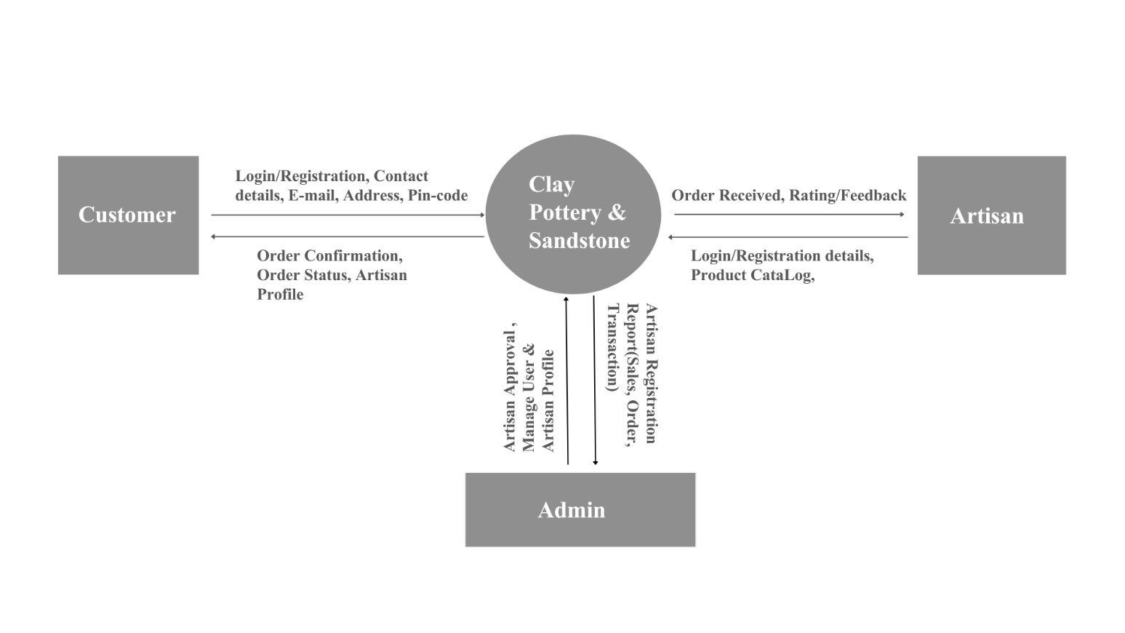
DFD: Level-0

DFD: Level-1

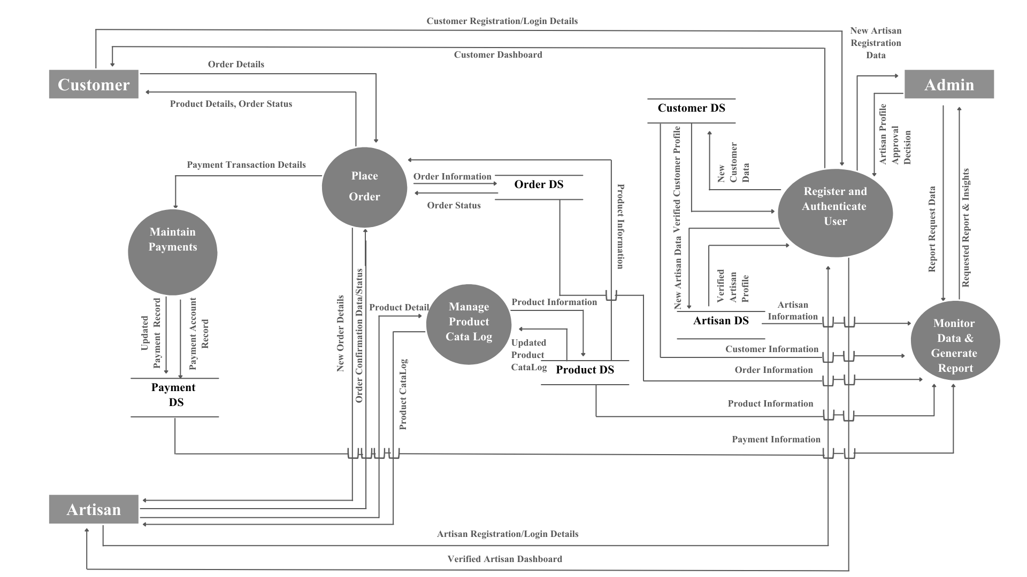

5.2 Entity Relationship (ER Diagram)

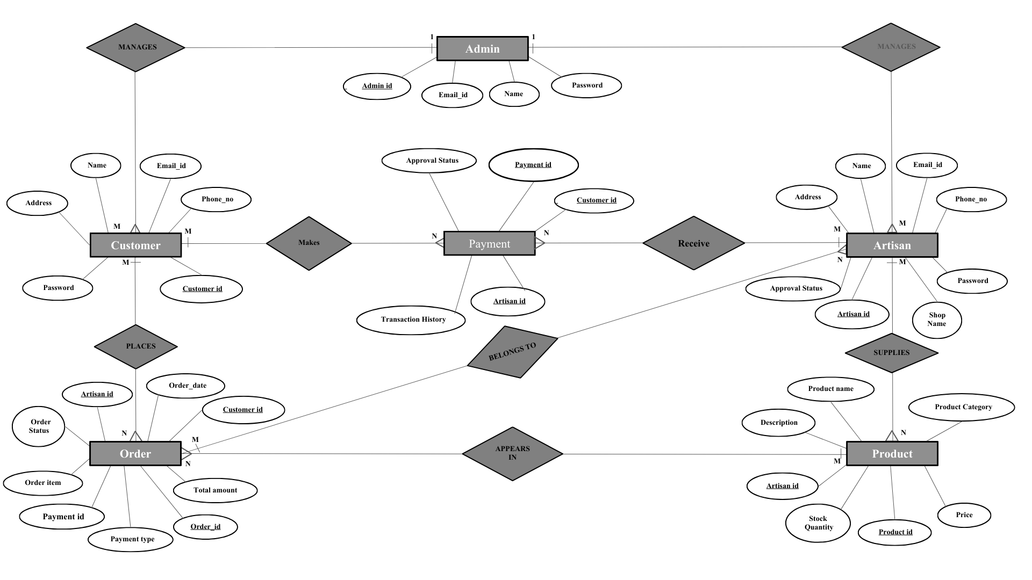

6. CONCLUSION

This project successfully presents an e-commerce platform for Clay Pottery and Sandstone products that helps local artisans showcase and sell their handcrafted items online. The system provides a direct connection between artisans and customers.

The platform makes it easy for customers to browse products, view details, and place orders from anywhere. It also supports digital promotion of traditional Indian handicrafts and helps artisans reach a wider national and international market.

Overall, this project demonstrates how digital technology can support small-scale artisans, preserve traditional art, and create better income opportunities through an organized and user-friendly online system.

FUTURE SCOPE

Although the system fulfills the basic requirements of an e-commerce platform, it can be further improved and expanded in the future. Some possible enhancements are:
- Development of a mobile application for better accessibility.
- Integration of advanced search and filter options for products.
- Multi-language support to reach a larger customer base.
- AI-based product recommendation system for personalized shopping.
- Integration of international shipping and logistics tracking.
- Addition of seller analytics and reports for artisans to monitor sales and performance.
- Improved security features and scalability to handle more users and products.
These future enhancements can make the platform more powerful, efficient, and competitive in the global
handicraft market.

BIBLIOGRAPHY

- Aggarwal, K.K. (2005). Software engineering, New Age International.
- Gupta, A.K. (2007). Taxonomy of Database Management System.
Firewall Media.
- https://www.geeksforgeeks.org/software-engineering/what-is-dfddata-flow-diagram/
- https://www.geeksforgeeks.org/dbms/introduction-of-er-model/
- YouTube (Gate Smeshers)

